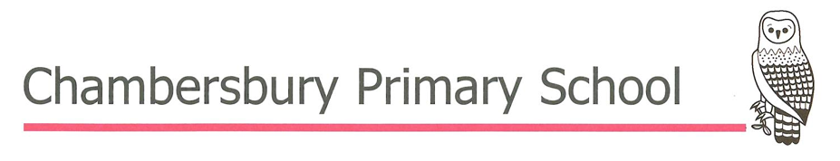
Writing at Chambersbury
Intent
At Chambersbury Primary School, we believe that writing empowers children to communicate, create and make a difference. In line with our vision of Learning, Growing, Achieving... TOGETHER, we are committed to ensuring that every child is cared for, valued and respected as they develop into confident, creative and purposeful writers. We want every pupil to recognise that their voice matters and that writing enables them to express ideas, share experiences, influence others and make a positive contribution to their community, society and the wider world.
Through our carefully sequenced writing curriculum, pupils progressively develop the knowledge and skills needed to write effectively for a wide range of audiences and purposes. High-quality and diverse texts provide inspiring models of language and expose pupils to ambitious vocabulary, enabling them to understand how authors craft writing before developing their own voice. As they progress through the school, pupils become increasingly confident in making deliberate choices about vocabulary, language, sentence structure and organisation to communicate with clarity, precision and purpose.
Writing develops imagination, curiosity, resilience and critical thinking. It encourages pupils to reflect upon their experiences, consider different perspectives and communicate with confidence and empathy. We want every child to leave Chambersbury as a confident communicator who takes pride in their writing and understands the power of words to inform, inspire and create positive change.

Implementation
Writing is taught daily through our carefully sequenced curriculum, underpinned by the Herts for Learning Essential Writing approach and informed by the principles of the Writing Framework. High-quality texts, engaging experiences and purposeful discussion provide meaningful contexts for writing whilst exposing pupils to ambitious vocabulary, varied language structures and effective models of writing.
Children develop as writers through a carefully planned writing process that includes immersion in high-quality texts and experiences, purposeful talk and oral rehearsal, explicit teaching, teacher modelling, shared and guided writing, independent application and regular opportunities to evaluate, revise, edit, redraft and publish their work.
Teachers create language-rich classrooms where pupils' ideas are valued and discussion is purposeful. Through explicit teaching and skilled modelling, children develop the confidence to articulate their thinking before applying it within increasingly sophisticated writing.
Vocabulary, grammar, punctuation and spelling are taught within meaningful writing contexts wherever possible so that pupils understand not only how language works, but why writers make particular choices to shape meaning and achieve their intended effect. As pupils progress, they become increasingly independent in selecting language, manipulating sentence structures and refining their writing.
Writing is valued across the curriculum, enabling pupils to communicate their understanding effectively across a range of subjects. Adaptive teaching, carefully planned scaffolds and high expectations ensure that all pupils, including those with SEND and EAL, access the full curriculum and achieve success as writers.
Presentation is valued highly. Through the consistent teaching of Letter-join handwriting and high expectations for presentation, pupils develop fluent, legible handwriting and take pride in producing work of a high standard.

Impact
The impact of our writing curriculum is that pupils leave Chambersbury Primary School as confident, articulate and increasingly independent writers who communicate effectively for a wide range of audiences and purposes. They write with increasing accuracy, fluency and creativity, selecting vocabulary, grammar and organisational structures deliberately to achieve their intended effect.
Pupils confidently evaluate and improve their writing, drawing upon their reading and wider experiences to craft engaging, purposeful texts. They demonstrate resilience throughout the writing process and understand that thoughtful revision and refinement are integral to producing high-quality writing.
As confident communicators and lifelong learners, pupils leave Chambersbury equipped with the knowledge, skills and aspirations to succeed in the next stage of their education and beyond. They understand that writing is a powerful tool for communication and positive change, enabling them to become thoughtful change-makers and positive assets within their community, society and the wider world.

