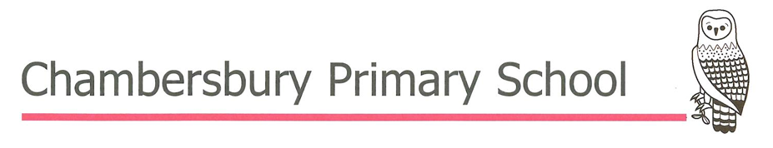
Reading and Phonics at Chambersbury
Intent
At Chambersbury Primary School, we believe that reading is fundamental to pupils' success across the curriculum and in life beyond school. In line with our vision of Learning, Growing, Achieving... TOGETHER, we are committed to ensuring that every child is cared for, valued and respected as they develop into fluent, confident and enthusiastic readers. We want every pupil to read with accuracy, understanding and enjoyment, equipping them with the knowledge, skills and cultural capital needed to thrive in an ever-changing world and to become thoughtful, informed change-makers and assets within their community, society and the wider world.
Through a carefully sequenced reading curriculum, pupils progressively develop reading fluency, vocabulary, understanding, retrieval, inference, knowledge of literature and an appreciation of language, structure and authorial intent. Carefully selected, high-quality and diverse texts enable pupils to see themselves reflected in what they read while broadening their understanding of different people, cultures and experiences. Reading nurtures curiosity, empathy, resilience and critical thinking, supporting pupils to become lifelong learners who embody our school values of Together, Honesty, Patience, Forgiveness, Kindness and Caring.
Implementation
Early reading and phonics
Early reading is taught through the systematic teaching of phonics using the Essential Letters and Sounds (ELS) programme. Phonics lessons take place daily and follow a clear, progressive sequence. Pupils are given regular opportunities to practise blending and segmenting so that decoding becomes increasingly secure and automatic. Reading books from the ELS scheme are closely matched to pupils’ current phonic knowledge, ensuring that they can apply what they have learned with confidence.
Assessment takes place regularly through the ELS Assessment for Learning (AfL) process, alongside half-termly assessment using Phonics Tracker. This enables teachers to identify gaps quickly, provide timely intervention and ensure that pupils keep up rather than catch up. Reading books are carefully matched to each pupil's secure phonic knowledge so that success builds confidence, fluency and automaticity.

Reading Lessons
Key Stage 1
In Key Stage 1, guided reading is delivered through carefully planned small-group sessions using texts that are closely matched to pupils' current reading attainment. Teachers explicitly develop reading fluency by modelling accurate, expressive reading and supporting pupils to read with increasing accuracy, automaticity and confidence. Through high-quality discussion, pupils develop vocabulary, understanding, retrieval, inference and prediction, while learning to justify their ideas using evidence from the text. Ongoing assessment ensures that teaching is carefully matched to pupils' needs and supports pupils in becoming increasingly fluent and independent readers.

Key Stage 2
In Key Stage 2, guided reading builds upon pupils' fluency to develop increasingly sophisticated reading knowledge and skills. Through carefully selected fiction, non-fiction and poetry, pupils explicitly develop vocabulary, understanding, retrieval and summarising, inference, and their understanding of language, structure and authorial intent. They are taught to justify their thinking using evidence from the text, compare ideas across texts and develop a secure knowledge of literature and different text types. Structured discussion and purposeful questioning deepen comprehension, extend vocabulary and build background knowledge. Ongoing assessment ensures that teaching remains responsive to pupils' needs, while Accelerated Reader supports, monitors and promotes independent reading.
Whole class reading
Daily whole-class reading provides opportunities for teachers to model fluent, expressive reading while exposing pupils to ambitious, high-quality texts beyond those they can yet access independently. Carefully planned discussion develops vocabulary, background knowledge and understanding, enabling pupils to make meaningful connections across the curriculum and appreciate how language, structure and authorial choices shape meaning. These shared reading experiences broaden pupils' horizons, deepen cultural understanding and inspire a lifelong love of reading.
Reading for pleasure
Reading for pleasure is central to our reading culture and underpins our belief that every child should develop a lifelong love of books. Classrooms provide inviting reading environments with a wide range of carefully selected, high-quality and diverse texts that promote curiosity, enjoyment and independent choice. Families are valued partners in developing positive reading habits, and pupils are encouraged to read regularly both at school and at home.
Throughout the year, pupils celebrate reading through events such as World Book Day, reading challenges and shared reading experiences. Older pupils regularly read with younger children during house group assemblies, fostering a strong community of readers where recommendations, discussion and a shared enjoyment of books reflect our commitment to learning, growing and achieving together.
Impact
The impact of our reading curriculum is that pupils leave Chambersbury Primary School as fluent, confident and enthusiastic readers who read widely, think deeply and communicate thoughtfully. They develop secure word recognition alongside strong language comprehension, enabling them to access the full curriculum and achieve their potential across all subjects.
Pupils confidently discuss and recommend books, justify their ideas using evidence from texts and appreciate how authors use language and structure to influence the reader. They leave Chambersbury with a broad knowledge of literature, a genuine love of reading and the confidence to continue reading independently throughout their lives. As lifelong learners, they are well prepared for the next stage of their education and equipped with the knowledge, values and aspirations to become thoughtful change-makers and positive assets within their community and the wider world.

