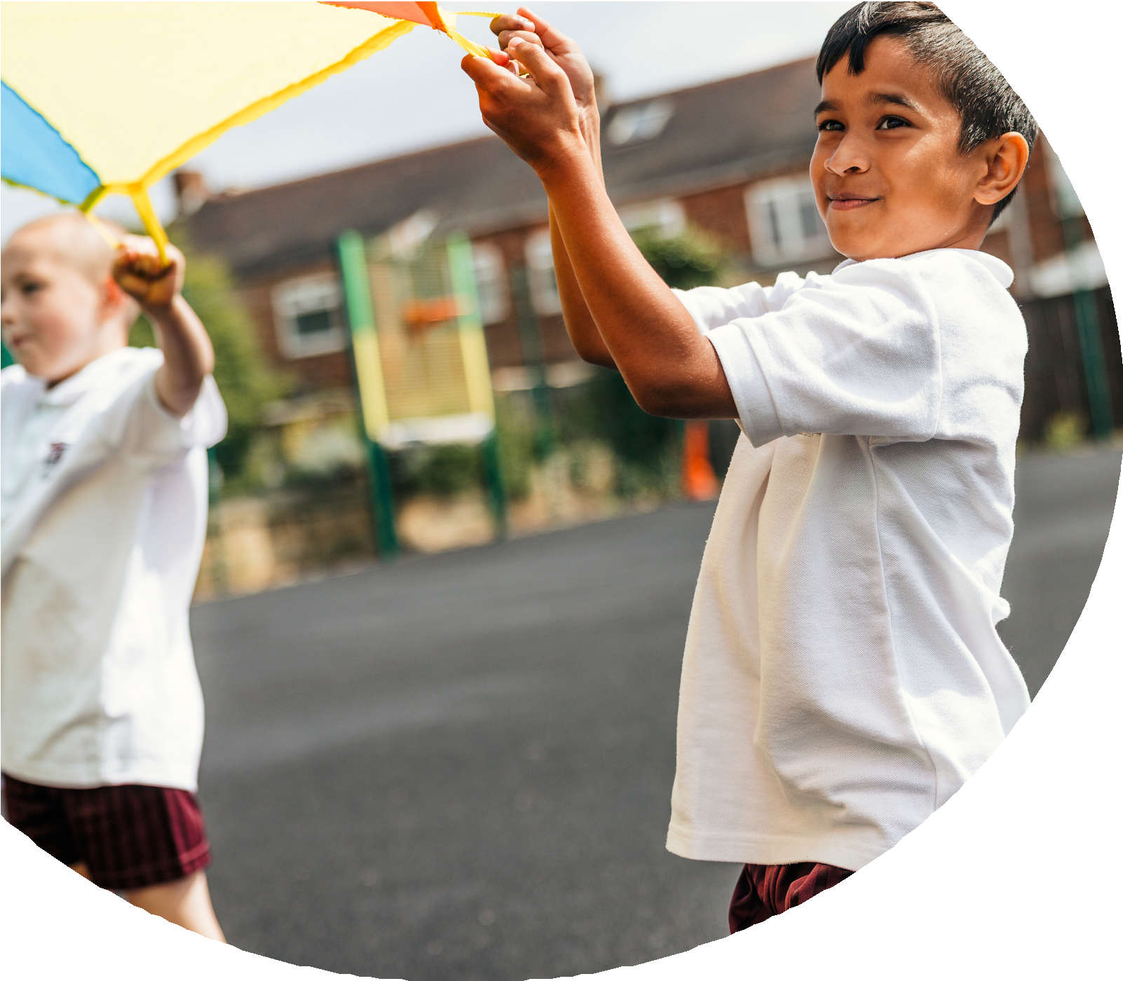
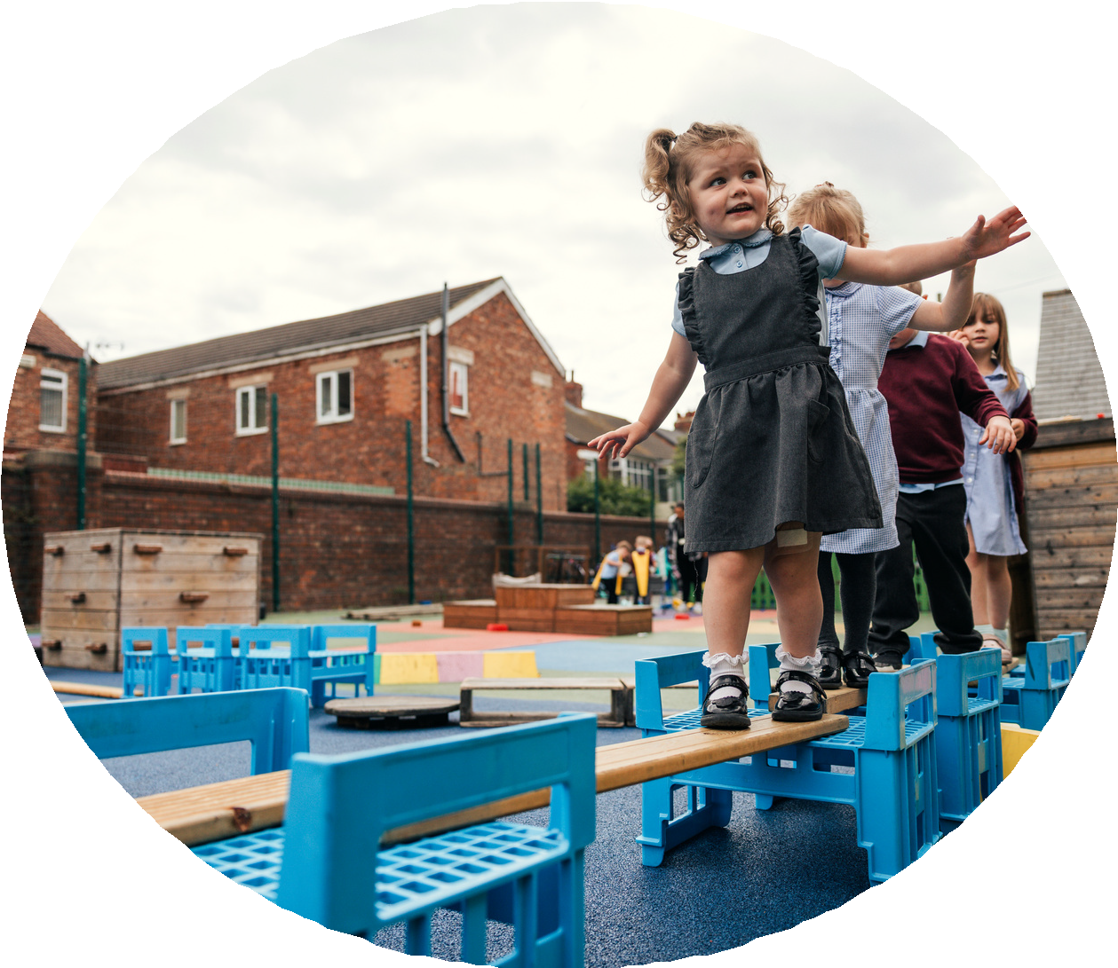

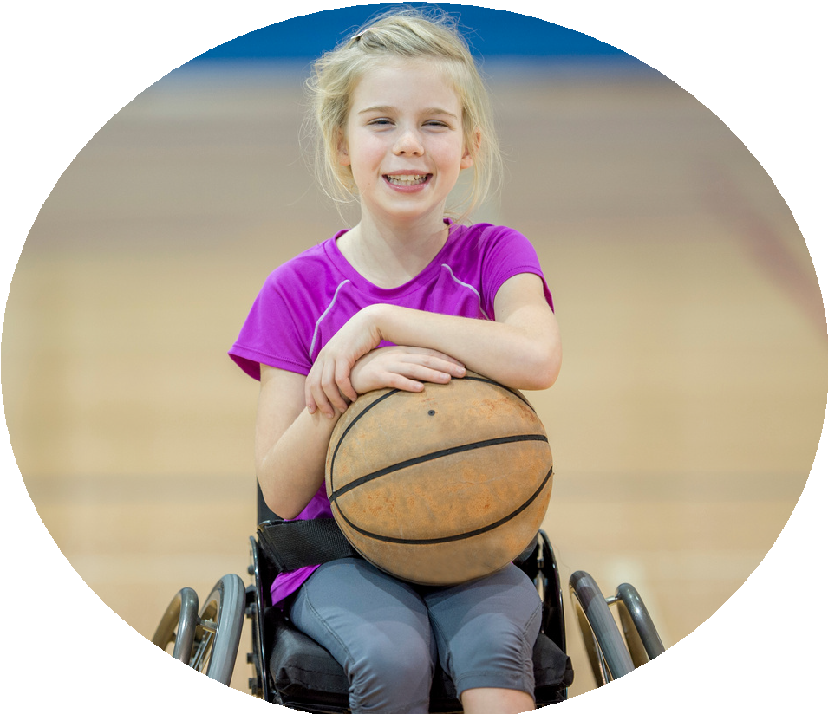



PE and sport premium monitoring and tracking form 2025/2026

Commissioned by

Created by


PE and sport premium monitoring and tracking form
- It is intended that this template should be used as preparation for the completion of the statutory DfE PE and sport premium digital expenditure reporting return. You can upload data (including swimming) from this template onto this platform once it becomes accessible.
- The template is a working document that you can amend and update during the year.
- Before you decide how you are going to use the funding for this academic year you should reflect and evaluate the impact of your use of you PE and sport premium funding in 2024/25.
- You should use your evaluation of last year’s funding to help you decide what to do this academic year, how you will do it, and what impact you expect it to have.
- All spending of the funding must conform with the terms outlined in the conditions of grant
- The summative digital expenditure reporting from June 2026 will continue to include swimming and water safety information. PE and sport premium funding can be used to provide top-up lessons, where necessary, to ensure pupils meet national curriculum swimming requirements
- To ensure funding is used effectively and based on your school’s needs; guidance and examples of best practice across schools can be found here.
- You must use the funding to make additional and sustainable improvements to the PE and sport in your school.
- You must develop and add to the PESSPA activities that your school already offers.

Useful Links:
- Complete the PE and sport premium expenditure reporting return - GOV.UK
- PE and sport premium for primary schools - GOV.UK
- PE and sport premium: conditions of grant 2024 to 2025 - GOV.UK

- It is intended that this template should be used as preparation for the completion of the statutory DfE PE and sport premium digital expenditure reporting return. You can upload data (including swimming) from this template onto this platform once it becomes accessible.
- The template is a working document that you can amend and update during the year.
- Before you decide how you are going to use the funding for this academic year you should reflect and evaluate the impact of your use of you PE and sport premium funding in 2024/25.
- You should use your evaluation of last year’s funding to help you decide what to do this academic year, how you will do it, and what impact you expect it to have.
- All spending of the funding must conform with the terms outlined in the conditions of grant
- The summative digital expenditure reporting from June 2026 will continue to include swimming and water safety information. PE and sport premium funding can be used to provide top-up lessons, where necessary, to ensure pupils meet national curriculum swimming requirements
- To ensure funding is used effectively and based on your school’s needs; guidance and examples of best practice across schools can be found here.
- You must use the funding to make additional and sustainable improvements to the PE and sport in your school.
- You must develop and add to the PESSPA activities that your school already offers.

Useful Links:
Complete the PE and sport premium expenditure reporting return - GOV.UK
PE and sport premium for primary schools - GOV.UK
PE and sport premium: conditions of grant 2024 to 2025 - GOV.UK

Review of the last academic year (2024/2025)

Swimming and Water Safety | What went well? Supporting evidence? | What didn't go well? Supporting evidence?
1. Swim competently, confidently and proficiently over a distance of at least 25 metres | We have a swimming pool every 3 years and all children swim at least twice in their time at Chambersbury.  50 % of our current year 6s can swim competently, confidently and proficiently over a distance of at least 25 metres. | N/A
2. Use a range of strokes effectively (for example, front crawl, backstroke and breaststroke) | We have a swimming pool every 3 years and all children swim at least twice in their time at Chambersbury.  50 % of our current year 6s can swim competently, confidently and proficiently over a distance of at least 25 metres using a range of strokes | N/A
3. Perform safe self-rescue in different water-based situations | We have a swimming pool every 3 years and all children swim at least twice in their time at Chambersbury.  50 % of our current year 6s can swim competently, confidently and proficiently over a distance of at least 25 metres using a range of strokes and can perform safe self-rescue | N/A
- Take some time to reflect on your intent, implementation and impact from last academic year to celebrate your wins but to also think about improvements for the year ahead.
- You do not need to complete every box. Just record the information that is key to your school's priorities and areas of focus.
Remember - Be clear about how you focussed spending on key groups such as SEND, girls and disadvantaged pupils.

Review of the last academic year (2025/2026)
Key areas as outlined in PE and sport premium guidance | What went well? Supporting evidence? | What didn't go well? Supporting evidence?
1. Increasing confidence, knowledge and skills of all staff in teaching PE and sporting activities prioritising CPD and training where needed | The PE Coordinator attended a regional PE conference, bringing back current best practice and new ideas to enhance the school's PE provision. New partnerships were established with external providers, securing a range of free taster sessions and broadening the sporting opportunities available to pupils. Staff continued to receive informal support and guidance from the PE Coordinator where required, helping to maintain the quality of PE provision. A clear vision for PE development has been established, with staff training and professional development identified as a key priority for the next academic year. Significant progress was made towards achieving the School Games Gold Mark by expanding the range of extracurricular clubs, competitions and sporting opportunities available to pupils, increasing participation across the school. | There were limited opportunities for formal PE CPD during the year, meaning staff confidence and subject knowledge were not developed as much as planned. A more structured programme of CPD, staff meetings, lesson study and specialist coaching will be implemented next year to further improve the quality and consistency of PE teaching across the school.
2. Increasing engagement of all pupils in regular physical activity and sporting activities | A wide range of opportunities were provided for pupils to be physically active throughout the school day, including PE lessons, active lunchtimes, extracurricular clubs, Healthy Living Week and competitive sport. 104 out of 175 pupils (59%) participated in at least one extracurricular sports club, with 41% of participants being pupils eligible for Pupil Premium, SEND, or both, demonstrating strong engagement from targeted groups. Lunchtime clubs and activities increased opportunities for pupils to be active beyond curriculum PE, encouraging positive play and healthy lifestyles. Monitoring of pupils' activity levels showed that 70% of pupils achieve an average of 60 minutes of physical activity each day, providing a strong foundation to build upon. More than 90% of pupils were recognised through Weekly Sports Stars, Half-Termly Sports Stars and celebration assemblies, helping to motivate children to take part in physical activity. Sports Ambassadors supported the promotion of physical activity across the school, encouraging participation and positive attitudes towards sport.  Healthy Living Week gave every child the opportunity to experience a variety of exciting sports and activities delivered by specialist coaches, increasing enthusiasm for being active. | Although participation increased, 30% of pupils are still not achieving the recommended 60 minutes of physical activity each day, highlighting the need for further targeted initiatives.  Sports Ambassadors require additional responsibilities and leadership opportunities to have a greater impact on increasing daily physical activity across the school.  The Active 60 initiative was not embedded consistently throughout the school day and will be developed further next year.  The Active Breakfast Club would benefit from a wider range of structured physical activities to encourage greater participation.  More pupil voice will be gathered to identify barriers to participation and ensure activities reflect children's interests.  A whole-school active travel initiative (walking, cycling and scooting to school) will be introduced next year to further increase daily physical activity beyond the school day.
3. Raising the profile of PE and sport across the school, to support whole school improvement | PE and school sport continued to have a high profile across the school, helping to create a culture where physical activity, participation and achievement are valued by pupils, staff and parents. Healthy Living Week was a major success, providing all pupils with the opportunity to take part in a wide range of activities delivered by specialist coaches, broadening their sporting experiences and inspiring them to lead active lifestyles. The school achieved the School Games Gold Mark, recognising the school's commitment to providing high-quality PE, school sport and physical activity opportunities. The range of extracurricular clubs increased, giving more pupils opportunities to participate in sport beyond curriculum PE lessons. The school entered more inter-school competitions than in the previous academic year, allowing more pupils to represent the school. For the first time in the school's history, a netball team was established, providing pupils with an additional competitive sporting opportunity. The mixed football team continued to flourish, with over 30 pupils representing the school throughout the year. Sporting achievements were celebrated through Weekly Sports Stars, Half-Termly Sports Stars, celebration assemblies, newsletters and social media, raising the profile of PE across the whole school community. Pupil voice showed that children have a genuine enthusiasm for PE and school sport. | Although PE has a high profile, there are further opportunities to celebrate pupils' sporting achievements outside of school, recognising successes in local clubs and community sport.  More opportunities should be created for pupils to take on leadership roles through the Sports Ambassador programme, helping to promote PE and physical activity across the school.  Greater parental engagement could be developed by sharing more information about sporting events, competitions and opportunities to be active at home.  Further links with local sports clubs and community providers will be established to provide clear pathways for pupils wishing to continue participating in sport outside school.  The school will continue to broaden the range of sports promoted to ensure every child can find an activity they enjoy and remain physically active.
4. Offer a broader and more equal experience of a range of sports and physical activities to all pupils and ensure equal access to sport for boys and girls | The school significantly broadened the range of sports and physical activities available through curriculum PE, extracurricular clubs, Healthy Living Week and competitive events.  Every pupil had the opportunity to experience a variety of sports through specialist coaching and taster sessions, encouraging children to discover new interests and develop lifelong participation in physical activity.  For the first time in the school's history, a netball team was established, widening the range of competitive opportunities available to pupils.  The school successfully ran a mixed football team, ensuring both boys and girls had the opportunity to represent the school in competitive football.  The range of extracurricular clubs increased, providing opportunities for pupils of different ages, abilities and interests to participate in physical activity.  Activities were planned to be as inclusive as possible, with opportunities available for pupils with SEND and those eligible for Pupil Premium to participate alongside their peers.  Pupil voice showed that children enjoyed having a greater choice of sports and valued the opportunities to try new activities throughout the year. | Although a mixed football team was offered, the school did not have a girls-only football team. Establishing a dedicated girls' football team will be a priority next year to further increase female participation and provide additional competitive opportunities.  Whilst the range of sports increased, further opportunities are needed to engage pupils who are less interested in traditional team sports by introducing activities such as yoga, fitness, dance, boccia or alternative sports.  More targeted opportunities will be developed for pupils with SEND to ensure they can access a broad range of sports through appropriate adaptations and support.  Pupil voice will continue to inform future club and activity provision, ensuring that all pupils have access to sports that reflect their interests and encourage lifelong participation.  Greater links with local sports clubs will be developed to provide clear pathways for boys and girls to continue participating in sport outside school.
5. Increasing participation in competitive sport | All pupils across the school had the opportunity to participate in competitive sport through a combination of intra-school competitions, inter-school events and house competitions.  The school entered more competitions than in the previous academic year, enabling a greater number of pupils to represent the school.  Opportunities were provided for children of all abilities to experience competition in a supportive environment, helping to develop confidence, resilience, teamwork and sportsmanship.  The school established its first-ever netball team, increasing the range of competitive sports available to pupils.  The mixed football team continued to grow, with over 30 pupils representing the school throughout the year.  Competitive sport played a key role during Healthy Living Week, where pupils took part in a range of house competitions and sporting challenges, encouraging participation and enjoyment.  The school successfully achieved the School Games Gold Mark, recognising its commitment to providing high-quality competitive sporting opportunities. | Although all pupils had the opportunity to participate in competitive sport, Reception children had fewer competitive opportunities than older year groups.  More age-appropriate competitive festivals, multi-skills events and house competitions will be introduced for Reception pupils next year to ensure they experience competition from the start of their school journey.  Greater opportunities will be developed for less confident pupils to take part in inclusive competitive events, ensuring competition remains accessible and enjoyable for everyone.  The school will continue to broaden the range of competitions entered to provide opportunities across an even wider variety of sports and activities.

Aims for the next academic year (2026/2027)
- Using your whole school priorities, school development plan and previous PE, school sport and physical activity data, set out your aims for the year ahead.
- Think about specific areas of need such as inactive girls, SEND and disadvantaged pupils
- Remember to also input your swimming data and reflections in the table located at the bottom of this page.
- Consider which of the 5 key areas improvements will be focussing on:
- Increasing confidence, knowledge and skills of all staff in teaching PE and sporting activities prioritising CPD and training where needed.
- Increasing engagement of all pupils in regular physical activity and sporting activities
- Raising the profile of PE and sport across the school, to support whole school improvement
- Offer a broader and more equal experience of a range of sports and physical activities to all pupils and ensure equal access to sport for boys and girls
- Increasing participation in competitive sport
Swimming and Water Safety | Input data | Reflections
1. Swim competently, confidently and proficiently over a distance  of at least 25 metres | We have a swimming pool every 3 years and all children swim at least twice in their time at Chambersbury.  50 % of our current year 6s can swim competently, confidently and proficiently over a distance of at least 25 metres.
2. Use a range of strokes effectively  (for example, front crawl, backstroke and breaststroke) | We have a swimming pool every 3 years and all children swim at least twice in their time at Chambersbury.  50 % of our current year 6s can swim competently, confidently and proficiently over a distance of at least 25 metres using a range of strokes
3. Perform safe self-rescue in different water-based situations | We have a swimming pool every 3 years and all children swim at least twice in their time at Chambersbury.  50 % of our current year 6s can swim competently, confidently and proficiently over a distance of at least 25 metres using a range of strokes and can perform safe self-rescue

Aim | Why? | Key area | Supporting evidence
Improve the confidence and competence of all staff in delivering high-quality PE through a structured CPD programme. | Whilst informal support was available, staff did not receive enough planned PE-specific professional development this year due to the focus on achieving the School Games Gold Award. High-quality teaching is the biggest factor in improving pupils' outcomes in PE. | Quality of Education / Staff Development | PE conference attended by PE Lead; limited whole-staff CPD delivered. Staff feedback identified a need for greater coaching, mentoring and subject-specific training.
Increase daily physical activity so that at least 80% of pupils achieve an average of 60 active minutes each day. | Monitoring showed that 70% of pupils currently achieve 60 active minutes daily. Further work is needed through Active 60, active travel, active playtimes and an enhanced Active Breakfast Club. | Physical Activity | Activity monitoring showed 70% achieving the recommended daily activity. Active 60 and Active Breakfast provision require further development.
Develop a more inclusive PE and school sport offer for girls, SEND pupils, Pupil Premium pupils and Reception children. | Although participation has increased, opportunities can be broadened further through targeted provision, adapted activities and increased competitive opportunities for younger pupils and underrepresented groups. | Equality, Diversity & Inclusion | No girls-only football team; Healthy Living Week could be more inclusive for SEND and Pupil Premium pupils; Reception children had fewer competitive opportunities.
Strengthen pupil leadership by developing the Sports Ambassador programme. | Sports Ambassadors have made a positive contribution but require greater responsibility to influence participation, organise activities, gather pupil voice and promote healthy lifestyles. | Leadership & Personal Development | Sports Ambassadors were established but need clearly defined leadership roles and responsibilities to maximise their impact.
Broaden the range of sports and strengthen community links to encourage lifelong participation. | Providing a wider variety of sports will help engage pupils who are less interested in traditional team games while creating clear pathways into community sport. | Enrichment & Wider Opportunities | First-ever netball team established; mixed football team successful; pupils requested a wider variety of activities and stronger links with local clubs.
Increase opportunities for competitive sport for all pupils, with a particular focus on Early Years and girls' football. | Every child participated in competitive sport this year; however, Reception pupils had fewer opportunities and there was no girls-only football team. Expanding competition will ensure equality of opportunity for all pupils. | Competitive Sport | All pupils accessed competitive sport; Reception competitions were limited; mixed football team successful but no girls-only team available.
Aims for the next academic year (2026/2027)

Plan, monitor and evaluate (2026/2027)
- Please aim to use this as a live working document through the year.

- Keep returning to this to evidence adaptations and progress made through the PESSPA opportunities you provide.

- There is no set number of objectives you must have.

- Make as many or as few as you see fit that will support your aims for the year ahead.

- Consider which of the 5 key areas improvements will be focussing on:
- Increasing confidence, knowledge and skills of all staff in teaching PE and sporting activities prioritising CPD and training where needed.
- Increasing engagement of all pupils in regular physical activity and sporting activities
- Raising the profile of PE and sport across the school, to support whole school improvement
- Offer a broader and more equal experience of a range of sports and physical activities to all pupils and ensure equal access to sport for boys and girls
- Increasing participation in competitive sport

Plan, monitor and evaluate (2026/2027)

Example objective shown below is for reference purposes only:
 | Intent – what is your objective? | Implementation - How will you achieve this? | Impact - What do you hope to see? | Supporting evidence
Plan and monitor | Develop lunchtime play provision to increase activity for least active groups. | Develop pupil leadership (training programme), Midday supervisor training, Staff CDP to develop their understanding of games and play, Range of equipment, Youth voice activities to understand pupils wants and needs Outdoor play provision such as OPAL | A confident and competent group of activity leaders that take initiative and create a more active and inclusive playground for all pupils. Midday supervisors and all staff leading a range of physical activities and joining in with movement daily to role model. A happier, more active playground that meets the needs of all pupils especially SEND and girls. | Youth voice data through half-termly surveys and interviews/group discussions with a variety of pupils (leaders, children participating and those that are less active at break times). Conduct regular observations of the playground to gauge activity levels of the least active children. Staff voice and feedback
 | What impact have you seen? | Are the improvements sustainable? How? | Supporting evidence | Approx. cost
Evaluate | Activity leaders are leading a broad range of activities and actively seeking children that are not engaged in physical activity during lunch times. Midday supervisors have grown in confidence and far more active and engaged in games with the children. Lunch times are more active with children having fun. Activity options have been tailored to suit the needs of SEND pupils through considerate choices of equipment and the types of games played. Girls are proving to be the hardest group to engage as some are still choosing not to be active | Continued training for activity leaders and bringing new leaders into the group to bring new ideas and expertise. More leaders will also mean more activities are able to be delivered. Continued training with midday supervisors. Establish lead midday supervisors to empower them and give them ownership. Continue to listen to SEND pupils and tailor activities to their needs and wants. Focus priorities on engaging girls. Work with least active girls to create activities that are meaningful and enjoyable for them. Do they want to be activity leaders for younger children to give them purpose and confidence? | 100 out of 100 activity leaders want to carry on with this role next year. 30 more children have enquired to joining the team. Meetings and the end of year survey have shown all leaders feel positive and enjoy making a difference for others. Interviews by random selection were conducted and 92% of pupils were either 'happy' or 'very happy' with the activities on offer at lunch time. End of year physical activity survey findings such as:  - Am I involved with games at lunch time - 89% Yes  - Do I enjoy lunch time? 97% Yes  - Have I joined in with a game with the activity leaders? 100% Yes | Physical Resources - £1000  CPD for staff - £500  OPAL - £8000
Your Objective:

 | Intent – what is your objective? | Implementation - How will you achieve this? | Impact - What do you hope to see? | Supporting evidence
Plan and monitor | 100% of teaching staff receive at least three PE CPD opportunities during the year. | • Deliver termly PE staff meetings focused on identified areas for development.  • Provide lesson observations, coaching and mentoring from the PE Lead and external specialists.  • Share good practice through team teaching and peer observations.  • Ensure staff attend local PE conferences and network meetings where appropriate. | Staff confidence and subject knowledge will improve, resulting in consistently high-quality PE lessons, greater pupil engagement and improved progress across all year groups. | CPD register, staff questionnaires, lesson observations, learning walks, staff meeting agendas, PE monitoring records.
 | What impact have you seen? | Are the improvements sustainable? How? | Supporting evidence | Approx. cost
Evaluate

Your Objective:

 | Intent – what is your objective? | Implementation - How will you achieve this? | Impact - What do you hope to see? | Supporting evidence
Plan and monitor | 80%+ of pupils achieve an average of 60 active minutes each day. | • Embed Active 60 across the school day.  • Introduce a structured Active Breakfast Club.  • Develop active playtimes using Sports Ambassadors.  • Promote active travel initiatives such as Walk to School Week and scooter/cycle challenges.  • Continue to monitor physical activity levels each term. | More pupils will achieve the Chief Medical Officer's recommendation of 60 active minutes each day, leading to improved fitness, concentration, wellbeing and behaviour. | Active 60 monitoring, pupil surveys, Breakfast Club registers, Sports Ambassador records, active travel participation data.
 | What impact have you seen? | Are the improvements sustainable? How? | Supporting evidence | Approx. cost
Evaluate

Your Objective:
 | Intent – what is your objective? | Implementation - How will you achieve this? | Impact - What do you hope to see? | Supporting evidence
Plan and monitor | A girls' football team is established and participates in local competitions. | • Launch a girls-only football club and enter local competitions.  • Plan inclusive sporting opportunities for SEND and Pupil Premium pupils.  • Organise Reception multi-skills festivals and intra-school competitions.  • Continue to monitor participation by different pupil groups. | Participation across all groups will become more equitable, with increased confidence, enjoyment and representation in school sport. Girls, SEND, Pupil Premium and Reception pupils will all have increased opportunities to participate and compete. | Club registers, competition entries, participation data by group, pupil voice, photographs, newsletters and School Games records.
 | What impact have you seen? | Are the improvements sustainable? How? | Supporting evidence | Approx. cost
Evaluate

Your Objective:
 | Intent – what is your objective? | Implementation - How will you achieve this? | Impact - What do you hope to see? | Supporting evidence
Plan and monitor | Reception pupils participate in at least three competitive festivals or house events during the year. | • Plan Reception-friendly multi-skills festivals each term.  • Introduce EYFS house competitions linked to fundamental movement skills.  • Work with local schools and the School Games Organiser to access Early Years festivals.  • Celebrate participation through assemblies and newsletters. | Reception pupils will develop confidence, teamwork and positive attitudes towards competition from an early age, ensuring they are well prepared for KS1 sporting opportunities. | Competition calendar, EYFS participation records, photographs, pupil voice, newsletters and School Games evidence.
 | What impact have you seen? | Are the improvements sustainable? How? | Supporting evidence | Approx. cost
Evaluate

Your Objective:

 | Intent – what is your objective? | Implementation - How will you achieve this? | Impact - What do you hope to see? | Supporting evidence
Plan and monitor | Sports Ambassadors lead weekly physical activity initiatives, support competitions and gather pupil voice each term. | • Train Sports Ambassadors at the beginning of the year.  • Allocate leadership responsibilities for playtimes, lunchtime activities and competitions.  • Conduct termly pupil voice surveys.  • Involve Sports Ambassadors in promoting Healthy Living Week and sporting events. | Pupils will take greater ownership of physical activity, leadership skills will develop and participation in sport and active play will increase across the school. | Sports Ambassador action plans, leadership logs, pupil voice surveys, photographs, assembly records and PE monitoring.
 | What impact have you seen? | Are the improvements sustainable? How? | Supporting evidence | Approx. cost
Evaluate

This page has been left blank for any notes or supporting information.

